Chapter 10, Problem 4.

Compute v_{o}(t) in the circuit of Fig. 10.53.

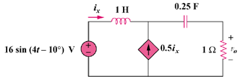

Figure 10.53
For Prob. 10.4.

